
Plot No.2, Sector 17-A, Yamuna Expressway,
Greater Noida, Gautam Budh Nagar, U.P., India

School of Computer Science And
Engineering


Lab Report
B. Tech- II Sem
2023-24
Engineering Mathematics-II(Lab)
(C1UC222B)

Submitted by: Submitted to:
Name: Gaurav. Dr. Vishal Singh sir
Section: 30(P1)
Admission number:23SCSE1180306
Index

Experiment - 01

**Write a sci lab code for the following problems: **

1.(i) Create a row vector with 3 elements.
Code:- A=[1 2 3]
disp("Row vector with 3 elements=" ,A)

Output:-
"Row vector with 3 elements="
1. 2. 3.
(ii) Create a column vector with 4 elements.
Code:- A=[1;2;3;4]
disp("Column vector with 4 elements=",A,A)

Output:-
"Column vector with 4 elements="
1.
2.
3.
4.
2. By taking the first term a=1 and the last term b=10 create a vector :
(i) by taking the spacing between two consecutive terms d=2.
Code:- A=[0:2:10]
disp(A)

Output:- 0. 2. 4. 6. 8. 10.

(ii) by taking the number of terms n= 12
Code:- A=linspace(0,10,12)
disp(A)

Output:-
0. 0.9090909 1.8181818 2.7272727 3.6363636 4.5454545 5.4545455 6.3636364 7.2727273 8.1818182 9.0909091 10.

3. Create two-row vectors a and b such that the following operations are defined and hence find:
(i) 2a-3b,
Code:- clc
clear
A A=[1 2 3]
disp("A=",A)
B=[4 5 6]
disp("B=",B)
C C=(2*A)-(3*B)
disp("2*A-3*B=",C)

Output:- "A="
1. 2. 3.
"B="
4. 5. 6.
"2*A-3*B="
-10. -11. -12.

(ii)2(transpose a)-3(transpose b).
Code :- clc
clear
A=[1 2 3]
disp("A=",A)
B=[4 5 6]
disp("B=",B)
C=(2*A’)-(3*B’)
disp("Answer=",C)
Output:-
"A="
1. 2. 3.
"B="
4. 5. 6.
"Answer="
-10.
-11.
-12.
4. Find the angle between the following pair of vectors
(i) (0,0),(1,1)
Code :- clc
clear
A=[0 0]
disp("A=",A)
disp("Norm(A)=",norm(A))
B=[1 1]
disp("B=",B)
disp("Norm(B)=",norm(B))
C=acosd(A*B’/(norm(A)*norm(B)))
disp("Angle between the both vector=",C)

Output:- "A="
0. 0.
"Norm(A)="
0.
"B="
1. 1.
"Norm(B)="
1.4142136
"Angle between the both vector="
Nan
(ii) (1,2), (0,1)
Code :- clc
clear
A=[1 2]
disp("A=",A)
disp("Norm(A)=",norm(A))
B=[0 1]
disp("B=",B)
disp("Norm(B)=",norm(B))
C=acosd(A*B’/(norm(A)*norm(B)))
disp("Angle between the both vector=",C)

Output:-
"A="
1. 2.
"Norm(A)="
2.2360680
"B="
0. 1.
"Norm(B)="
1.
"Angle between the both vector="
26.56505
(iii) (0,1,0), (1,2,1)
Code :- clc
clear
A=[0 1 0]
disp("A=",A)
disp("Norm(A)=",norm(A))
B=[1 2 1]
disp("B=",B)
disp("Norm(B)=",norm(B))
C=acosd(A*B’/(norm(A)*norm(B)))
disp("Angle between the both vector=",C)

Output:-
"A="
0. 1. 0.
"Norm(A)="
1.
"B="
1. 2. 1.
"Norm(B)="
2.4494897
"Angle between the both vector="
35.264390
(iv) (1,2,3), (2,3,4)
Code :- clc
clear
A=[1 2 3]
disp("A=",A)
disp("Norm(A)=",norm(A))
B=[2 3 4]
disp("B=",B)
disp("Norm(B)=",norm(B))
C=acosd(A*B’/(norm(A)*norm(B)))
disp("Angle between the both vector=",C)

Output:-
"A="
1. 2. 3.
"Norm(A)="
3.7416574
"B="
2. 3. 4.
"Norm(B)="
5.3851648
"Angle between the both vector="
6.9824973
5. Draw the arrows for the following vectors:
(i) (1,2) (ii) (2,5)

Code :- clc
clear
clf
plot2d([0,0])
xarrows([0,1],[0,2],3,3);
Output:-
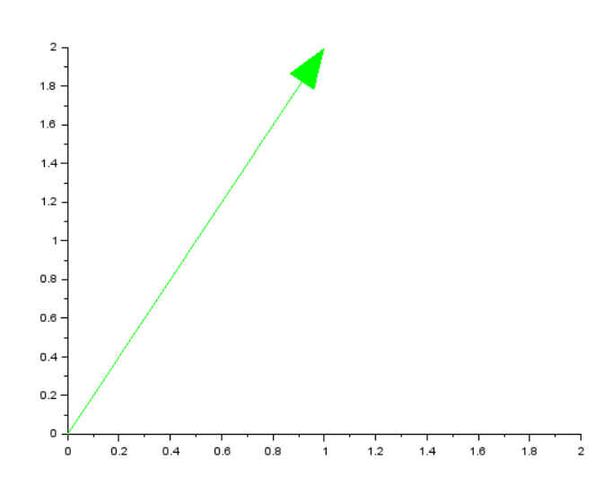
(ii) (2,5)
Code :- clc
clear
clf
plot2d([0,0])
xarrows([0,2],[0,5],4,4);

Output:-
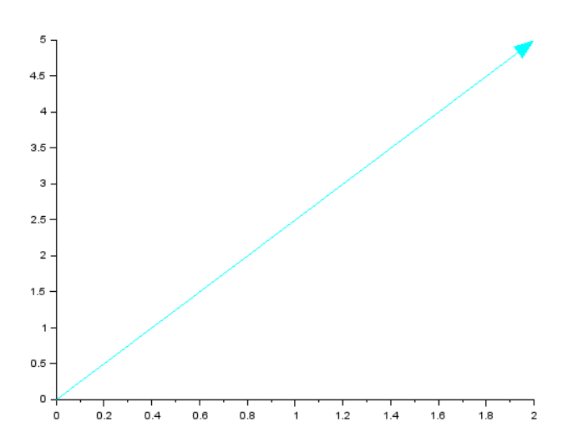
(iii) (0,7)
Code :- clc
clear
clf
plot2d([0,0])
xarrows([0,0],[0,7],2,5);
Output:-
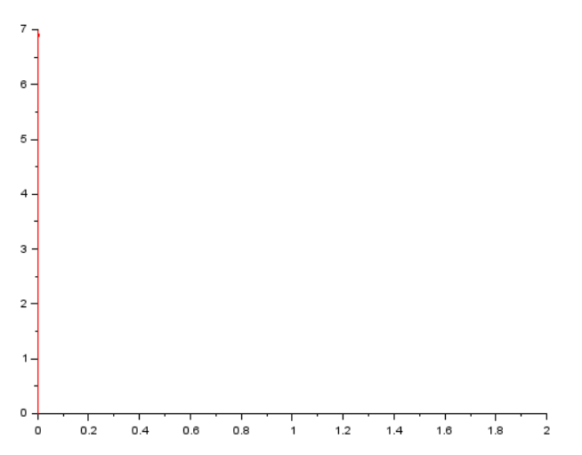
(iv) (1,2,3)
Code :- clc
clear
clf
plot3d([0,1,1],[0,1,1],[0,1,1],[0,1,2])
xarrows([0,1],[0,2],[0,3],2,5);
Output:-
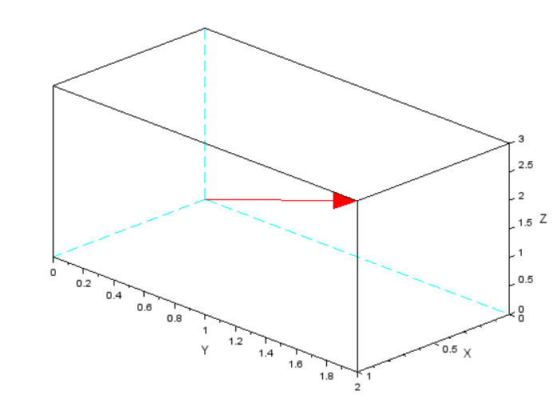
(v) (-1,0,1)
Code :- clc
clear
clf
plot3d([0,1,1],[0,1,1],[0,1,1],[0,1,2])
xarrows([0,-1],[0,0],[0,1],3,5);

Output:-
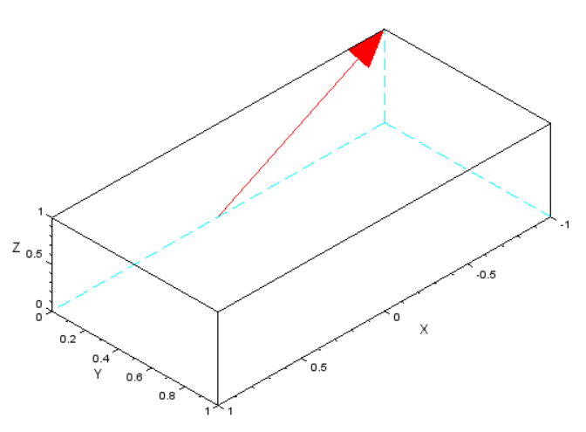
(vi) (0,1,-1)
Code :- clc
clear
clf
plot3d([0,1,1],[0,1,1],[0,1,1],[0,1,2])
xarrows([0,0],[0,1],[0,-1],2,7)
Output:-
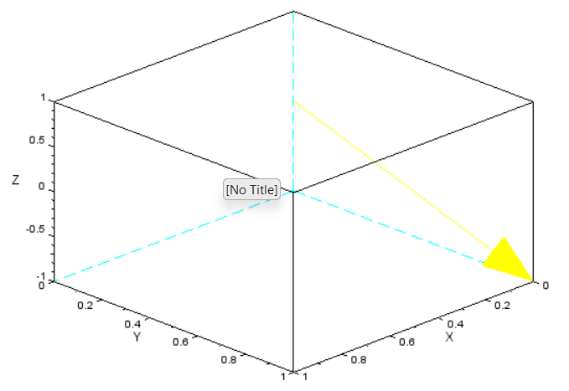
6. Find the polar coordinates of the following vectors and draw their arrows:
(i) (1,2)
Code:- clc
clear
clf
plot2d([0,0])
xarrows([0,1],[0,2],5,7)
theta= atand(2/1)
r=abs(sqrt(1**2+2**2))
disp("Theta=",theta)
disp("r=",r)
Output:-
"Theta="
63.434949
"r="
2.2360680
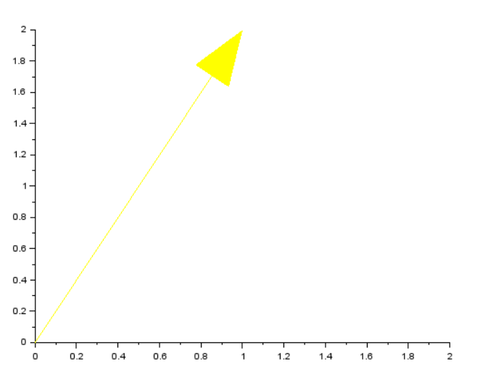
(ii) (2,5)
Code:- clc
clear
clf
plot2d([0,0])
xarrows([0,2],[0,5],3,2)
theta= atand(5/2)
r=abs(sqrt(2**2+5**2))
disp("Theta=",theta)
disp("r=",r)
Output:-
"Theta="
68.198591
"r="
5.3851648

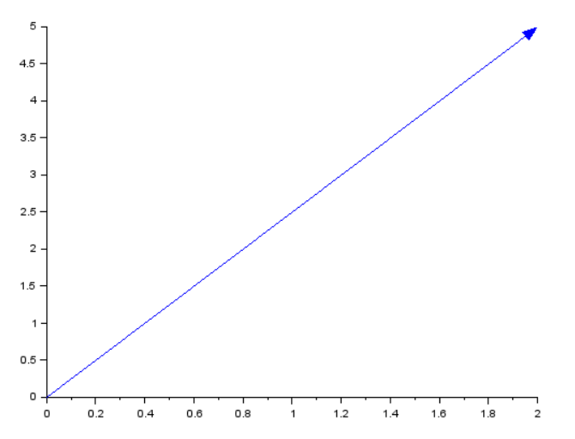(iii) (0,7)
Code:- clc
clear
clf
plot2d([0,0])
xarrows([0,0],[0,7],6,9)
theta= atand(7/0)
r=abs(sqrt(0**2+7**2))
disp("Theta=",theta)
disp("r=",r)
Output:-
"Theta="
90.
"r="
7.
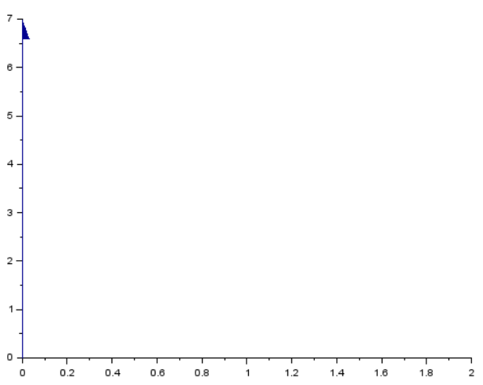

(iv) (1,2,3)
Code:- clc
clear
clf
plot3d([0,1,1],[0,1,1],[0,1,1],[0,1,2])
xarrows([0,1],[0,2],[0,3],4,5)
p phi=atand(2/1)
r=abs(sqrt(0**2+7**2+3**2))
theta=acosd(3/r)
disp("phi=",phi)
disp("r=",r)
disp("Theta=",theta)
Output:-
"phi="
66.801409
"r="
7.6157731
"Theta="
66.801409

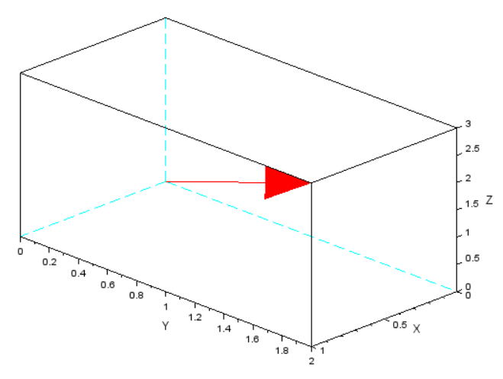

(v) (-1,0,1)

Code:- clc
clear
clf
plot3d([0,1,1],[0,1,1],[0,1,1],[0,1,2])
xarrows([0,-1],[0,0],[0,1],2,7)
p phi=atand(0/-1)
r=abs(sqrt(-1**2+0**2+1**2))
theta=acosd(1/r)
disp("phi=",phi)
disp("r=",r)
disp("Theta=",theta)
Output:-

